January to March 2022

|  |  |  |  |  |  |  |
| --- | --- | --- | --- | --- | --- | --- |
| **Title of Activities/Program** | **Date/ Duration** | **Documentation (Pictures)** | **Participants** | **Location** | **Conducted/ Sponsored by:** | **Budget/R emark** |
| **GUIDANCE AND COUNSELING ADMISSION AND TESTING UNIT** | | | | | | |
| University wide Meeting with Guidance counselors | January 25, 2022 | C:\Users\Guidance\Desktop\1st qtr pics\272061363_754160162224799_479661384394015024_n.jpg C:\Users\Guidance\Desktop\1st qtr pics\271781698_782335479826831_3931356727389825188_n.jpg  C:\Users\Guidance\Desktop\1st qtr pics\277690910_491886895755405_4158439395213344082_n.jpg | All guidance counselors and staff | WFH via zoom | Guidance office | Accomplis hed |

|  |  |  |  |  |  |  |
| --- | --- | --- | --- | --- | --- | --- |
| Virtual meeting with ICTS and NETLINK for 2nd semester online admission | January 31, 2022 |  | All guidance counselors, staff, ICTS and NETLINK | WFH via zoom | ICTS and NETLINK | Accomplis hed |

|  |  |  |  |  |  |  |
| --- | --- | --- | --- | --- | --- | --- |
| Start of online admission for transferees | February 7-18, 2022 | C:\Users\Guidance\Desktop\1st qtr pics\admission.png | Guidance counselors, staff, colleges and student applicants | Thru online system | Guidance office | Accomplis hed |
| Attended the webinar for PAG-IBIG members | February 8, 2022 |  | LSPU Employees | Via zoom | HRMO/PAG- IBIG | Accomplis hed |
| Virtual meeting with guidance counselors for system wide webinar with  Gary V | February 9, 2022 | *No pictures* | All guidance counselors and staff | WFH via g- meet | Guidance Office  /Gary V’s staff | Accomplis hed |

|  |  |  |  |  |  |  |
| --- | --- | --- | --- | --- | --- | --- |
| Conducted a “Gary V Virtual Face 2 Face webinar” | February 18, 2022 |  | Selected participants (LSPU employees) | Via Zoom | Guidance Office | Accomplis hed |
| Checked and verified enrolment requirements of transferee students qualified to enroll for second semester of AY 2021-2022 | March 1 – 11, 2022 | *No pictures*  46 requirements checked and verified | Guidance staff | LSPU –  Siniloan | Guidance office | Accomplis hed |

|  |  |  |  |  |  |  |
| --- | --- | --- | --- | --- | --- | --- |
| Administered EPI Test to BEED students of LSPU Lopez | March 31, 2022 | C:\Users\Guidance\Desktop\1st qtr pics\277091031_945361842828286_4499829653155706904_n.jpg  C:\Users\Guidance\Desktop\1st qtr pics\277743502_306530011621338_9036130826197284324_n.jpg  C:\Users\Guidance\Downloads\277823897_693996048458819_7694195169748514104_n.jpg | Guidance counselor/ Guidance Staff | LSPU Siniloan | Guidance Office | Accomplis hed |

|  |  |  |  |  |  |  |
| --- | --- | --- | --- | --- | --- | --- |
| Good moral certificate request | January – March 2022 | *No pictures*  167 good moral certificates released | Guidance staff | LSPU-Siniloan | Guidance office | Accomplis hed |
| Signing of clearance | January – March 2022 | *No pictures*  165 clearance signed | Guidance staff | LSPU-Siniloan | Guidance office | Accomplis hed |

|  |  |  |  |  |  |  |
| --- | --- | --- | --- | --- | --- | --- |
| **TITLE OF ACTIVITIES/ PROGRAM** | **DATE/DURATION** | **DOCUMENTATION (PICTURES)** | **PARTICIPANTS** | **LOCATION** | **CONDUCTED/ SPONSORED BY** | **BUDGET/REMARKS** |
| **STUDENT ORGANIZATION AND ACTIVITIES UNIT** | | | | | | |
| **Recognition of SBO and Societies** | | | | | | |
| Recognition of SBO and Societies | January 5, 2022 |  | Philippine Society of Agricultural and Biosystems Engineer - Pre Professional Group | LSPU OSAS | OSAS SOA UNIT |  |
|  |  | OFAD Society |  |  |
|  |  | Samahan ng mga Mag-aaral na may Espesyalisasyong Filipino (SMEF) |  |  |
|  |  | Society of Future Early Childhood Educators |  |  |

|  |  |  |  |  |  |  |
| --- | --- | --- | --- | --- | --- | --- |
|  |  |  |  |  |  |  |
| January 6, 2022 |  | Science Society  College of Computer Studies - Student Body Organization |  |
| February 2, 2022 |  | Junior Philippine Institute of Accountants  BSBA Society  Basic Education Mentors Society |  |

|  |  |  |  |  |  |  |
| --- | --- | --- | --- | --- | --- | --- |
|  |  |  | Values Advocate  College of Criminal Justice Education - Student Body Organization |  |  |  |
| February 3, 2022 |  | Student Body Organization of Future Mentors |  |
| February 14, 2022 |  | Sexuality and Gender Equality Council |  |

|  |  |  |  |  |  |  |
| --- | --- | --- | --- | --- | --- | --- |
|  | March 31, 2022 |  | SBO Senior High School |  |  |  |
| **Activities of Recognized SBO and Societies** | | | | | | |
| ABEmazing Tagisan ng Talino: Kaalaman mo Show mo  24th Luzon Wide Convention | January 2022  February - March 2022 |  | COE Students  BSABE students from different Universities in Luzon | LSPU SC | Philippine Society of Agricultural and Biosystems Engineer - Pre Professional Group |  |
| JPIA Next Tough Model | February 8-23, 2022 |  | BS ACCO Students | LSPU SC  Online Platform | Junior Philippine Institute of Accountants |  |

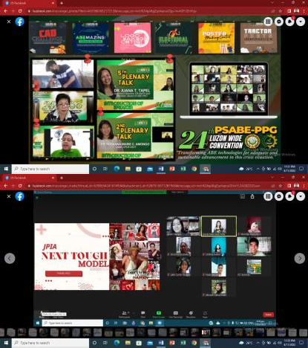

|  |  |  |  |  |  |  |
| --- | --- | --- | --- | --- | --- | --- |
| National Arts Month Celebration | February 11, 2022 |  | LSPU SC Students | LSPU SC  Online Platform | SBOFM |  |
| Good Talks with  Ma’am Allen | February 18,2022 |  | BSBA Students | LSPU SC  Online Platform | BSBA Society |  |
| Engineering Shirt Layout Contest | Feb 26, 2022 - March  17, 2022 |  | COE Students | LSPU SC  Online Platform | LSPU-SC ENGINEERING STUDENTS' GUILD |  |
| Virtual English Festival | March 15-18, 2022 |  | BSEd English Majors | LSPU SC  Online Platform | ELLSOC |  |
| Poster Making Contest - Buwan ng Kababaihan | March 21, 2022 |  | CTE Students | LSPU SC  Online Platform | SMEF |  |

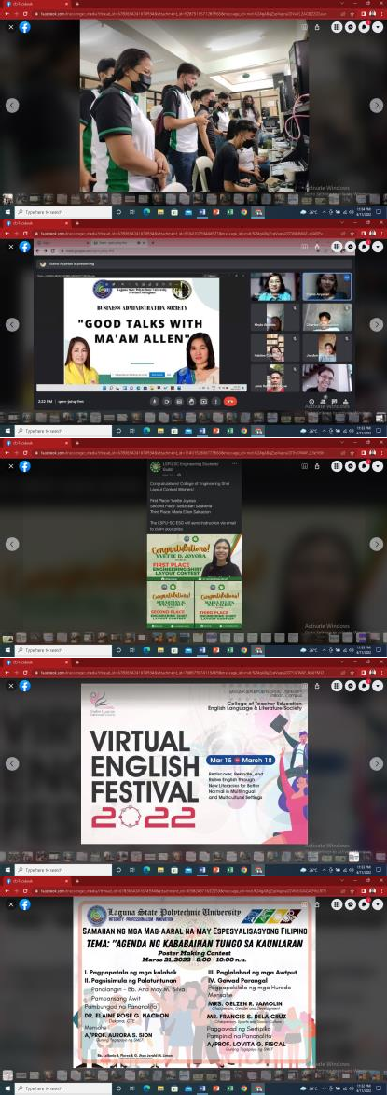

|  |  |  |  |  |  |  |
| --- | --- | --- | --- | --- | --- | --- |
| Creation and Promotion of SGEC page | - |  | SGEC Members | LSPU SC  Online Platform | SGEC |  |

|  |  |  |  |  |  |  |
| --- | --- | --- | --- | --- | --- | --- |
| **TITLE OF ACTIVITIES/ PROGRAM** | **DATE/DURATION** | **DOCUMENTATION (PICTURES)** | **PARTICIPANTS** | **LOCATION** | **CONDUCTED/ SPONSORED BY** | **BUDGET/REMARKS** |
| **STUDENT GOVERNMENT AND LEADERSHIP TRAINING UNIT** | | | | | | |
| Attended Zoom Meeting with Crisis Management Committee, LSPU Siniloan | January 13, 2022 |  | LSPU Crisis Management Commitee | Via Zoom Meeting | Crisis Management Committee | Accomplished |
| Attended LSPU- SC COE  consultation meeting on limited Face to Face Classes | February 11, 2022 |  | COE Students, Parents and Faculty | Via Zoom Meeting | College of Engineering | Accomplished |
| Virtual Feb Fair | February 11, 2022 |  | LSPU SC Students | LSPU Siniloan | Supreme Student Council and ICTS | Accomplished |

|  |  |  |  |  |  |  |
| --- | --- | --- | --- | --- | --- | --- |
| Recognition of the First LGBTQIA  Organization in LSPU Initiated by LSPU-SC SSC | February 14, 2022 |  | Sexuality and Gender Equality Council and Supreme Student Council | LSPU Siniloan | SSC, SGEC, SOA AND OSAS | Accomplished |
| Attended the PACSA  Convention 2022 | March 3-4, 2022 |  | National Campus Advisers and Student Leaders | Via Zoom Teleconference | PACSA | Accomplished |

|  |  |  |  |  |  |  |
| --- | --- | --- | --- | --- | --- | --- |
| Creation of SSC institutional Email | March 4, 2022 |  | Supreme Student Council | LSPU Siniloan | Supreme Student Council and ICTS | Accomplished |
| Attended Zoom Meeting with Crisis Management Committee, LSPU Siniloan | March 7, 2022 |  | LSPU Crisis Management Committe | Via Zoom Meeting | Crisis Management Commitee | Accomplished |

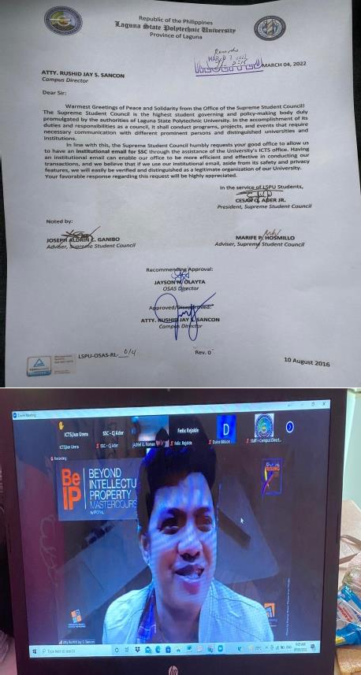

|  |  |  |  |  |  |  |
| --- | --- | --- | --- | --- | --- | --- |
| Disseminated the LSPU Health Declaration form to LSPU Students | March 11, 2022 |  | LSPU SC Students | Via Facebook page and Messenger Groupchat | Supreme Student Council, LSPU Clinic and ICTS. | Accomplished |
| Submitted a letter for the Procurement of SSC Computer Set, Printer and Office Supplies. | March 11, 2022 |  | Supreme Student Council | LSPU Siniloan | Supreme Student Council | Approved |

|  |  |  |  |  |  |  |
| --- | --- | --- | --- | --- | --- | --- |
| Gave the token and Certificate to Former SSC Advisers and Officers as sign of Appreciation for their Service. | March 15, 2022 |  | Supreme Student Council and Former SSC Officers and Advisers. | LSPU Siniloan | Supreme Student Council | Accomplished |
| Made an Ocular visit and evaluation on the areas covered for Limited Face to Face classes | March 29, 2022 |  | Crisis Management Committee | LSPU Siniloan | Crisis Management Committee | Accomplished |

|  |  |  |  |  |  |  |
| --- | --- | --- | --- | --- | --- | --- |
|  |  |  |  |  |  |  |

|  |  |  |  |  |  |  |
| --- | --- | --- | --- | --- | --- | --- |
| **Title of**  **Activities/Program** | **Date/**  **Duration** | **Documentation**  **( Pictures )** | **Participant(s)** | **Location** | **Conducted/**  **Sponsored by:** | **Remarks** |
| **GENDER AND DEVELOPMENT** | | | | | | |
|  |  |  | Ms. Gelzen R. Jamolin |  | Gender and |  |
|  |  |  | Via google | Development & |  |
| GAD and Sexuality And  Gender Equality Council (SGEC) Focused Group Discussion | January 20,  2022 | SGEC Officers  Cesar Q Ader, Jr. Francis Louie Bodino Renz Ivan Valdellon John Lourence Cads Jem Cabisidan Marlon Cenita Russel Ramos  Eidref Villanueva Arkansas Perez | meet | Sexuality And  Gender Equality Council (SGEC) | Accomplished |
|  |  | (2 female, 8 Male) |  |  |  |

|  |  |  |  |  |  |  |
| --- | --- | --- | --- | --- | --- | --- |
| Focused Group Discussion with the Student Services Committee | March 18,  2022 |  | Ms. Gelzen R. Jamolin Mr. Jayson N. Olayta Mr. Johnny Fernandez  (2 Male; 1 Female) San Pablo, Sta. Cruz and  Los Banos Capuses,  OSAS Chairpersons, Medical Team, Guidance & Special Needs Coordinators | LSPU San  Pablo City Campus  Face-to-face | Office of the Student Affairs and Services | Accomplished |

|  |  |  |  |  |
| --- | --- | --- | --- | --- |
| **ACTIVITIES** | **PERFORMANCE**  **MEASURES** | **ACCOMPLISHMENT** | **DOCUMENTATION** | **REMARKS** |
| **STUDENT PUBLICATION UNIT** | | | | |
| **Coverage of Virtual Feb Fair, February 12, 2022** | 2 of 2 assigned writer submitted the article on time | 1 news article with corresponding poster subject for the release of news letter |  | Accomplished |

|  |  |  |  |  |
| --- | --- | --- | --- | --- |
| **Feature of the Sexuality and Gender Equality Council, February 14, 2022** | 1 assigned member to write and cover the event submitted the article on time. 3 of 3 editors and 1 adviser were able to check and post the article on the desired date of  posting. | 1 feature article with corresponding poster subject for the release of news letter |  | Accomplished |
| **Coverage of CCJE Mental Health Awareness Webinar, February 24, 2022** | 1 assigned member to write and cover the event submitted the article on time. 3 of 3 editors and 1 adviser were able to check and post the article on the desired date of posting. | 1 news article with corresponding poster subject for the release of news letter |  | Accomplished |

|  |  |  |  |  |
| --- | --- | --- | --- | --- |
| **News Article of LSPU SC BLEPP Passers, February 26, 2022** | 2 of 2 assigned writers submitted the article on time. 3 of 3 editors and 1 adviser were able to check and post the article on the desired date of posting. | 1 news article with corresponding poster subject for the release of news letter |  | Accomplished |
| **Literary about National Arts Month, February 28, 2022** | 1 assigned member to write and cover the event submitted the article on time. 3 of 3 editors and 1 adviser were able to check and post the article on the desired date of posting. | 1 literary article with corresponding artwork subject for the release of news letter |  | Accomplished |

|  |  |  |  |  |
| --- | --- | --- | --- | --- |
| **Coverage of University-wide National Arts Month Celebration, February 28, 2022** | 2 of 2 assigned writers submitted the article on time. 3 of 3 editors and 1 adviser were able to check and post the article on the desired date of posting. | 1 news article with corresponding poster subject for the release of news letter |  | Accomplished |
| **Coverage of University-wide Consultative Meeting about Limited face- to-face Classes, March 10, 2022** | 1 assigned member to write and cover the event submitted the article on time. 3 of 3 editors and 1 adviser were able to check and post the article on the desired date of posting. | 1 news article with corresponding poster subject for the release of news letter |  | Accomplished |

|  |  |  |  |  |
| --- | --- | --- | --- | --- |
| **Release of Volume 1 Newsletter of the The Baybay Granary, March 13, 2022** | 16 of 16 assigned members were able to submit the assigned work on time. 2 of 2 editors were able to finish the layout before the desired time of posting. 2 0f 2 assigned editors checked the output including the adviser. | 16-page printed newsletter with soft copy posted online. |  | Accomplished |
| **Distribution of Volume 1 Newsletter to different offices of LSPU Siniloan, March 16, 2022** | 6 of 6 assigned members for distribution completed the task with 1 adviser. | 15 copies of 16-page printed newsletter |  | Accomplished |

|  |  |  |  |  |
| --- | --- | --- | --- | --- |
| **Coverage of LSPU SC National Women’s Month Celebration, March 24, 2022** | 1 assigned member to write and cover the event  submitted the article on time. 3 of  3 editors and 1 adviser were able to check and post the article on the desired date of posting. | 1 news article with corresponding poster subject for the release of news letter |  | Accomplished |
| **Literary about Women’s Month, March 31, 2022** | 1 assigned member to write and cover the event submitted the article on time. 3 of 3 editors and 1 adviser were able to check and post the article on the desired date of  posting. | 1 literary article with corresponding artwork subject for the release of news letter |  | Accomplished |

|  |  |  |  |  |
| --- | --- | --- | --- | --- |
| **Coverage of PSABE- PPG 24th Luzon-wide Convention, March 30-31** | 1 assigned member to write and cover the event submitted the article on time. 3 of 3 editors and 1 adviser were able to check and post the article on the desired date of posting. | 1 news article with corresponding picture subject for the release of news letter |  | Accomplished |

|  |  |  |  |  |  |  |
| --- | --- | --- | --- | --- | --- | --- |
| **Title of Activities/Program** | **Date/ Duration** | **Documentation (Pictures)** | **Participants** | **Location** | **Conducted/ Sponsored by:** | **Budget/Remark** |
| **SCHOLARSHIP AND FINANCIAL ASSISTANCE UNIT** | | | | | | |
|  |  |  |  |  | UniFast Unit of CHED | **Accomplished** |
|  |  | UniFast Unit of |  | Regional Office IV, |  |
| CHED ZOOM MEETING CREDENTIALS FOR TES 3B AND HEI HUB ORIENTATION | January 14,2022 | CHED Regional  Office IV, TES Focal  Person, Chairspersons and | LSPU Siniloan Scholarship Office | TES Focal Person,  Chairspersons and Staff |  |
|  |  | Staff |  |  |  |
|  |  |  |  | LSPU Siniloan Scholarship Office | UniFast Unit of CHED | **Accomplished** |
| CHED COORDINATION MEETING | January 28,2022 | UniFast Unit of CHED Regional Office IV, TES Focal Person, | Regional Office IV,  TES Focal Person, Chairspersons and Staff |  |
|  |  | Chairspersons and |  |  |
|  |  | Staff |  |  |
| ACADEMIC ADMIN COUNCIL MEETING | February 2,2022 |  | Admin Council | LSPU Siniloan | Admin Council | **Accomplished** |
| ACADEMIC ADMIN COUNCIL MEETING | February 14,2022 |  | Admin Council | LSPU Siniloan | Admin Council | **Accomplished** |

|  |  |  |  |  |  |  |
| --- | --- | --- | --- | --- | --- | --- |
| RELEASE OF STIPEND ALLOWANCE( TES SCHOLARS) 2ND SEM 2020- 2021 | February 21-  24,2022 |  | Chairperson, SFA Staff, Scholars | LSPU Siniloan Scholarship Office | Chairperson, SFA Staff, Cashier’s Office and Scholars | **Accomplished** |
| CHED COORDINATION MEETING | February 28,2022 |  | UniFast Unit of CHED Regional Office IV, TES Focal Person, Chairspersons and  Staff | LSPU Siniloan Scholarship Office | UniFast Unit of CHED Regional Office IV, TES Focal Person, Chairspersons and Staff | **Accomplished** |
| SFA MONTHLY MEETING  Friday via Google Meet | March 4,2022 | C:\Users\SCHOLARSHIP OFFICE\Desktop\GELINE ASEDILLO FILES\ACCOMPLISHMENTS REPORT FILE\first quarter 2022\sfa google meet.png | Chairpersons,SFA Staff, | LSPU Siniloan Scholarship Office | Chairperson, SFA Staff | **Accomplished** |
| ACADEMIC ADMIN COUNCIL MEETING | March 11,2022 |  | Admin Council | LSPU Siniloan | Admin Council | **Accomplished** |
| Release of stipend allowance | March 21-  25,2022 |  | Chairperson, SFA Staff, Scholars | LSPU Siniloan Scholarship Office | Chairperson, SFA Staff, Cashier’s Office and Scholars | **Accomplished** |

|  |  |  |  |  |  |  |
| --- | --- | --- | --- | --- | --- | --- |
| UniFAST Unit of CHED Regional Office IV will conduct a virtual orientation on the amended TES and TDP guidelines | March 30,2022 | C:\Users\SCHOLARSHIP OFFICE\Desktop\GELINE ASEDILLO FILES\ACCOMPLISHMENTS REPORT FILE\first quarter 2022\UNIFAST ORIENTATION MEETING 3-30-22.png | UniFast Unit of CHED Regional Office IV, TES Focal Person, Chairspersons and Staff | VIA ZOOM- LSPU  Siniloan Campus | LSPU Siniloan | **Accomplished** |

|  |  |  |  |  |  |  |
| --- | --- | --- | --- | --- | --- | --- |
| **LSPU-SC** | **Date/ Duration** | **Documentation (Pictures)** | **Participants** | **Location** | **Conducted**  **/ Sponsored by:** | **Budget/Re mark** |
| **HEALTH AND MEDICAL UNIT** | | | | | | |
| 1. Coordinated to RHU siniloan for the schedule of booster dose toLSPU employees | January 10, 2022 | **Thru Phone** | RHU employees | Thru phone | LSPU-SC  Nurse |  |
| 2. Made announcement for the schedule of booster dose to RHUSiniloan for those who are willing  to be vaccinated. | January-February 2022 | **Thru messenger** | LSPU-SC  employees | Thru messenger | LSPU-SC  Nurse |  |
| 3. Supervised/ Assisted the LSPU at the vaccination of booster dose | January 5, 2022 |  | LSPU-SC  employees | Siniloan vaccination site | LSPU-SC  Nurse |  |

|  |  |  |  |  |  |  |
| --- | --- | --- | --- | --- | --- | --- |
| 4. Coordinated to RHU siniloan for  the schedule of booster dose to LSPU employees | January to March | **Thru Phone** | RHU employees | Thru phone | LSPU-SC  Nurse |  |
| 5. Monitoring of quarantined employees | January to March |  | LSPU quarantined employees, Clinic personnel | Thru phone | LSPU-SC  Nurse |  |
| 6 Facilitated Physical examination for CTE students for their Field Study purposes | January 2022 |  | LSPU employees, LSPU Clinic personnel | LSPU-Sc  Clinic | LSPU-SC  Nurse |  |

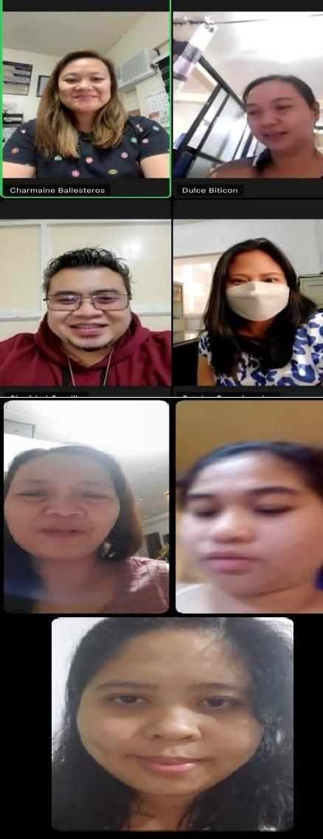

|  |  |  |  |  |  |  |
| --- | --- | --- | --- | --- | --- | --- |
| 7. Attended zoom meeting with my co-nurses with regards to the Mission of LSPU. Guidelines for Prevention and Control of COVID-19 Infection Policy | January 7, 2022 |  | LSPU Nurses | Thru zoom | LSPU-SC  nurse |  |
| 8. Facilitated virtual meeting with my clinic staff with regards to the updated guidelines and procedure for the quarantine employees | January 8, 2022 |  | Clinic Personnel | Thru zoom | LSPU-SC  Nurse |  |

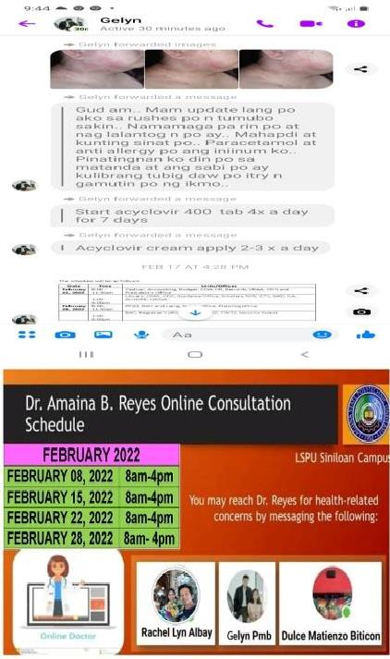

|  |  |  |  |  |  |  |
| --- | --- | --- | --- | --- | --- | --- |
| 9. Coordinated to RHU Sanitary Officers for the health protocol, new guidelines from DOH, issuance of medical certificate for the  employees to undergo quarantine | January to March 2022 | **Thru Phone** | RHU employees | Thru phone | LSPU-SC  Nurse |  |
| 10. Made online referralsfrom time to time to visiting physician with regards to medical concern of LSPU employees | January to March 2022 |  | Clinic Personnel | Thru phone | Clinic Personnel |  |
| 11. Made an announcement to group chat with regards to the online consultation of Dra. Reyes | January to March 2022 |  | LSPU-SC  employees | Thru messenger | LSPU-SC  Nurse |  |

|  |  |  |  |  |  |  |
| --- | --- | --- | --- | --- | --- | --- |
| 12. Attended zoom meeting with Crisis management committee, LSPU Siniloan | January 13, 2022 |  | LSPU Crisis Management committee | Thru Zoom | Crisis Management Committee |  |
| 13. Made a report with regards to the Quarantined faculty and staff of LSPU | January 13, 2022 |  | Clinic personnel | LSPU-SC  Clinic | LSPU-SC  Nurse |  |
| 14. Made contact tracing and telecare monitoring of close contact for positive to COVID-19 employees  and undergo quarantine | January 13, 2022 | **Thru Phone** | Close contact Employees | LSPU-SC  Clinic | LSPU-SC  Clinic personnel |  |

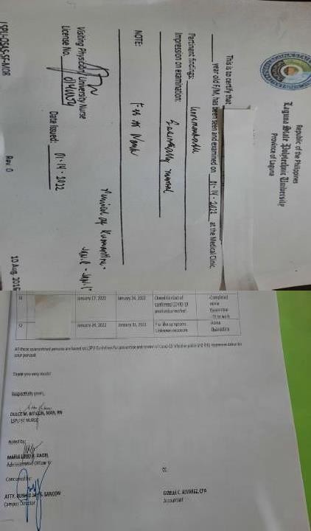

|  |  |  |  |  |  |  |
| --- | --- | --- | --- | --- | --- | --- |
| 15. Facilitated in giving medical certification and giving home instructions to all LSPU employees undergone quarantine | January to March 2022 |  | LSPU employees, LSPU Clinic personnel | LSPU-Sc  Clinic | LSPU-SC  Nurse |  |
| 16. Notified admin officials (CD, HR, accounting) for proper approval of Home Quarantine employees of LSPU | January to March 2022 |  | Admin Officials, LSPU Clinic personnel | LSPU-SC | LSPU-SC  Nurse |  |
| 17. Updated campus Director from time to time  with regards to the status of Quarantine employees | January to March 2022 |  | LSPU Clinic personnel, Campus Director | LSPU-SC  Clinic | LSPU-SC  Nurse |  |

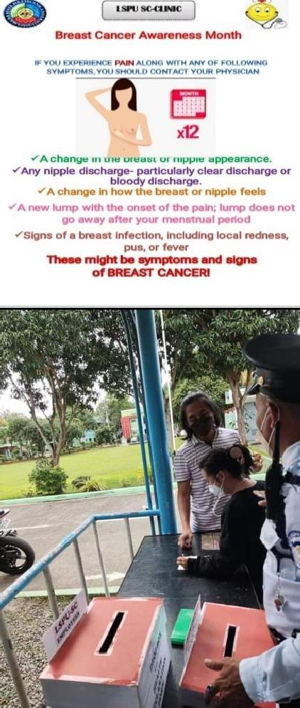

|  |  |  |  |  |  |  |
| --- | --- | --- | --- | --- | --- | --- |
| 18. Information dissemination  with regards to the health awareness month to be posted at LSPU-SC group chat | January to March 2022 |  | LSPU Clinic personnel | LSPU-SC  Clinic | LSPU-SC  Nurse |  |
| 19. Continuous implementation of Covid-  19 guidelines and protocols for the  prevention of  transmission | January to March 2022 |  | LSPU Clinic personnel | LSPU-SC  Clinic | LSPU-SC  Nurse |  |

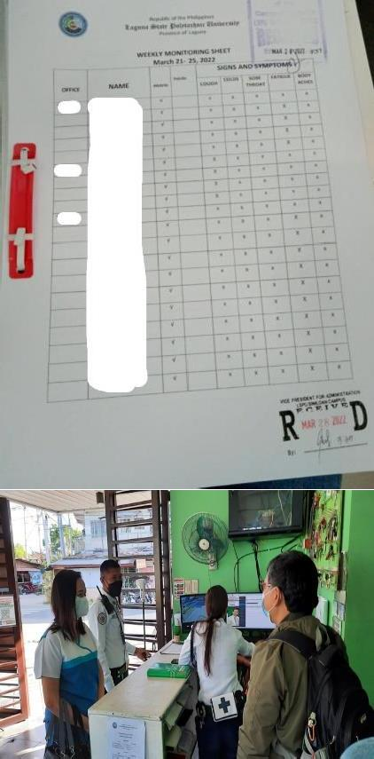

|  |  |  |  |  |  |  |
| --- | --- | --- | --- | --- | --- | --- |
| 20. Weekly telemonitoring of reporting employees with regards to the flu-like symptoms | January to March 2022 |  | LSPU Clinic personnel | LSPU-SC  Clinic | LSPU-SC  Nurse |  |
| 21. Coordinated and made am updated list of LSPU Quarantine employees to guard on duty for monitoring | January to March 2022 |  | LSPU Clinic personnel | LSPU-SC  Clinic | LSPU-SC  Nurse |  |
| 22. Giving instruction from time to time to my clinic  aide with regards to the health matters | January to March 2022 | **Thru Phone** | LSPU Clinic personnel | LSPU-SC  Clinic | LSPU-SC  Nurse |  |

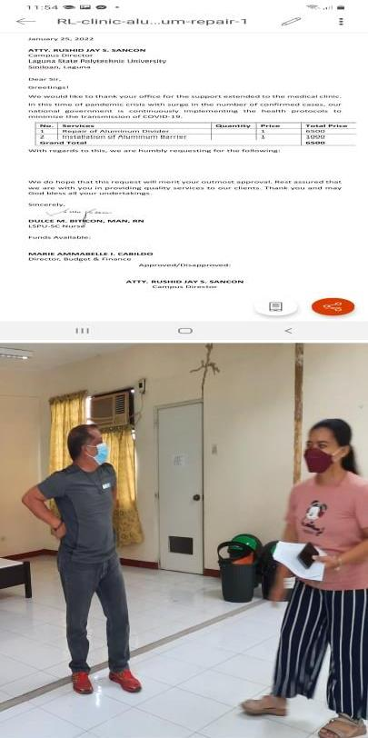

|  |  |  |  |  |  |  |
| --- | --- | --- | --- | --- | --- | --- |
| 23. Made a request letter for the pair and installationof aluminum barrier and clinic division. | January 24,2022 |  | LSPU Clinic personnel | LSPU-SC  Clinic | LSPU-SC  Nurse |  |
| 24.Coordination and inspection with the PPSD director of Sta. Cruz with regards to the recommendation of ISO room and needs of clinic for the repair and replacement materials | January 19, 2022 |  | PPSD director | LSPU-SC  Clinic | LSPU-SC  Nurse |  |

|  |  |  |  |  |  |  |
| --- | --- | --- | --- | --- | --- | --- |
| 25. Submitted a report to the HR with regards to the number of governments employees affected by COVID-19 from agencies in Laguna for the period of Dec. 16-31, 2021 and Jan. 1- 18, 2022 | January 28, 2022 |  | LSPU Clinic personnel, HR | LSPU-SC  Clinic | LSPU-SC  Nurse |  |
| 26.Attended administrative council meeting via zoom | February 2, 2022 |  | Admin Council | LSPU-SC  Clinic | Admin Officials |  |

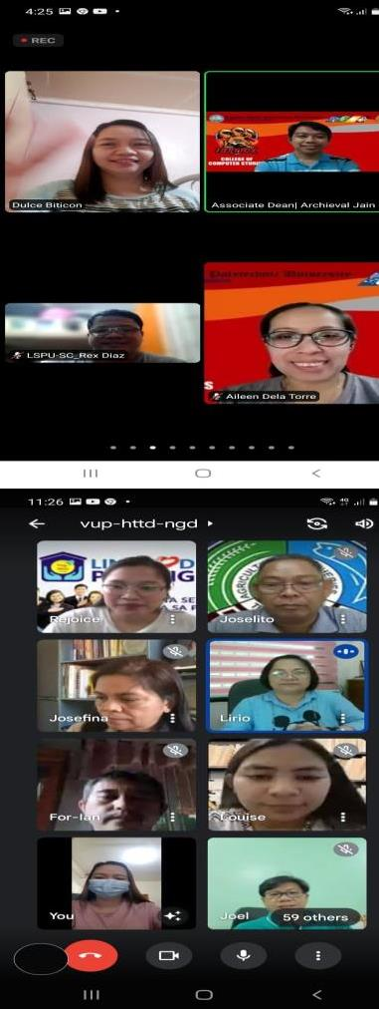

|  |  |  |  |  |  |  |
| --- | --- | --- | --- | --- | --- | --- |
| 27. Attended limited face to face classes public forum with the parents and students of CCS and LSPU-SC via zoom meeting | February 4, 2022 |  | Parents, CCS faculty | LSPU-SC  Clinic | CCS |  |
| 28.Attended Pag-ibig Fund Webinar | February 8, 2022 |  | LSPU Employees | LSPU-SC  Clinic | HR |  |

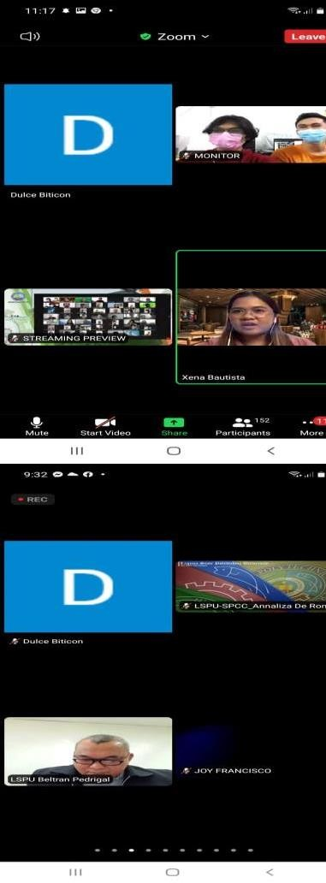

|  |  |  |  |  |  |  |
| --- | --- | --- | --- | --- | --- | --- |
| 29.Attended LSPU-SC COE consultation meeting on limited face to face | February 11, 2022 |  | Parents, COE faculty | LSPU-SC  Clinic | COE |  |
| 30. Attended LSPU full administrative council meeting | February 14, 2022 |  | LSPU Admin Council | LSPU-SC  Clinic | Admin Officials (President and VPA) |  |

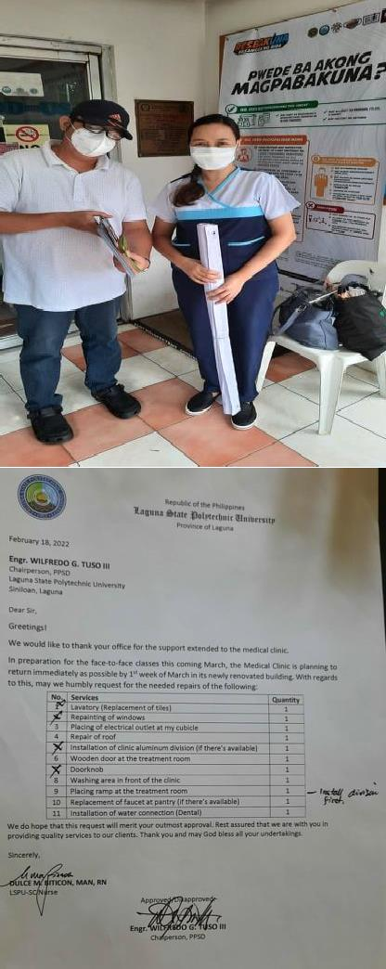

|  |  |  |  |  |  |  |
| --- | --- | --- | --- | --- | --- | --- |
| 31. Coordinated with the PHO thru phone with regards to the plan of activities related to Gender Advocacy development for Womenthis March | February 15, 2022 |  | PHO personnel | LSPU-SC  Clinic | LSPU-SC  Nurse |  |
| 32.Made a request letter for the needs to be repair of the clinic for the upcoming limited face to face | February 16, 2022 |  | LSPU Clinic personnel | LSPU-SC  Clinic | LSPU-SC  Nurse |  |

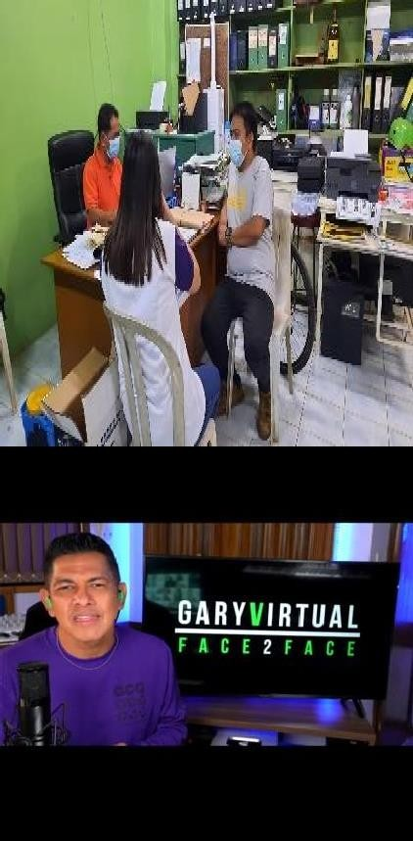

|  |  |  |  |  |  |  |
| --- | --- | --- | --- | --- | --- | --- |
| 33. Coordinated with PPSD chairperson with regards to the needs to be requested including the disinfectant solution of equipment. | February 18, 2022 |  | LSPU Clinic personnel, PPSD Chairperson | LSPU-SC  Clinic | LSPU-SC  Nurse |  |
| 34.Attended Gary V. Virtual face to face webinar | February 18, 2022 |  | LSPU employees | LSPU-SC  Clinic | Guidance Office |  |
| 35. Coordinated with the RHU-Siniloan for the update of the availability and schedule of booster  vaccine | February 18, 2022 | **Thru Phone** | LSPU Clinic personnel | Thru phone | LSPU-SC  Nurse |  |

|  |  |  |  |  |  |  |
| --- | --- | --- | --- | --- | --- | --- |
| 36. Provided First Aid treatment to LSPU employees such as removal of suturing on site | February 18, 2022 |  | LSPU Clinic personnel | LSPU-SC  Clinic | LSPU-SC  Nurse |  |

|  |  |  |  |  |  |  |
| --- | --- | --- | --- | --- | --- | --- |
| 37. Observed the health protocol for the release of CHED TES STIPEND allowance to our student grantees. | February 21, 2022 |  | LSPU Clinic personnel | LSPU-SC VOAG | LSPU-SC  Nurse |  |
| 38. Coordinated with the RHU-TB DOTS thru phone with regards to the schedule of sputum test to one of LSPU employees | February 23, 2022 | **Thru Phone** | LSPU Clinic personnel | Thru Phone | LSPU-SC  Nurse |  |
| 39. Coordinated with GAD Chairperson with regards to the plan of activities this coming March in celebration withthe  Women’s Month | February 22, 2022 to  March 25, 2022 | **Thru Phone** | LSPU-SC Nurse, Clinic Personnel and GAD Chairperson | LSPU-SC | LSPU-SC  Nurse and GAD  chairperson |  |

|  |  |  |  |  |  |  |
| --- | --- | --- | --- | --- | --- | --- |
| 40. Assisted the medical doctor for Annual Medical Examination for reporting non-teaching employees | February 22 and 28,  March 8 and 14, 2022 |  | LSPU Clinic personnel | LSPU-SC  Clinic | LSPU-SC  Nurse |  |

|  |  |  |  |  |  |  |
| --- | --- | --- | --- | --- | --- | --- |
| 41.Attended zoom meeting with my co-nurses regarding GAD’s plan of activities and other health matters | March 1, 2022 |  | LSPU Nurses | LSPU-SC  Clinic | LSPU  Nurses |  |
| 42.Coordinated to ABR with regards to blood chem and ask discount for our  employees | March 1, 2022 | **Thru Phone** | ABR personnel | LSPU-SC  Clinic | LSPU-SC  Nurse |  |
| 43. Assisted on the blood extraction during Blood chem | March 2, 2022 |  | LSPU Clinic personnel | LSPU-SC  Clinic | LSPU-SC  Nurse |  |

|  |  |  |  |  |  |  |
| --- | --- | --- | --- | --- | --- | --- |
| 44. Attended a University Wide meeting with the UDRMO and crisis committee with regards to the needs to be prepared and discussed self-assessment checklist on the readiness of HEI to re- open campuses for limited face to face classes as well as the Health Protocol for COVID-19 | March 4, 2022 |  | UDRRMO and Crisis Committee | LSPU-SCC | UDRRMO  and Crisis Committee |  |
| 45. Visited LSPU-SCC to see their isolation facilitythat we are plan to adoptfor the limited face to face classes | March 4, 2022 |  | LSPU-SC  concerned employees | LSPU-SCC | UDRRMO  and Crisis Committee |  |
| 46. Coordinated with the director of Physical and Plant with regards to the materials and supplies  needed specifically the | March 7, 2022 | **Thru Phone** | Nurse, PPSD Director | LSPU-SC | LSPU-SC  Nurse |  |

|  |  |  |  |  |  |  |
| --- | --- | --- | --- | --- | --- | --- |
| cubicle of the physician and repair of the clinic partition and ask for the  allotted budget. |  |  |  |  |  |  |
| 47. Attended of Crisis Management Committee meeting | March 7, 2022 |  | Crisis Management Committee | Thru zoom | Admin Officials and Crisis management Committee |  |

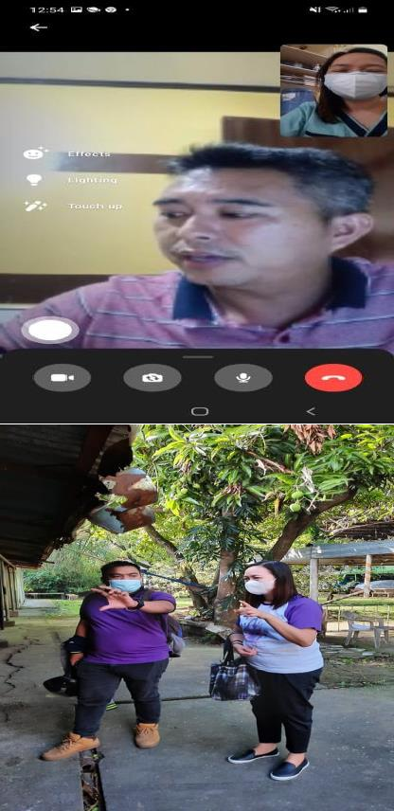

|  |  |  |  |  |  |  |
| --- | --- | --- | --- | --- | --- | --- |
| 48. Coordinated with the faculty president and SSC student president for the dissemination of Health Declaration google forms. | March 7, 2022 |  | faculty president and SSC student president | Thru zoom | LSPU-SC  Nurse |  |
| 49.Made inspection rounds together with the UDRRMO faculty president to check the planned holding area at the main gate. | March 8, 2022 |  | LSPU-SC Nurse and UDRRM Faculty President | LSPU-SC | LSPU-SC  Nurse and UDRRM  Faculty President |  |

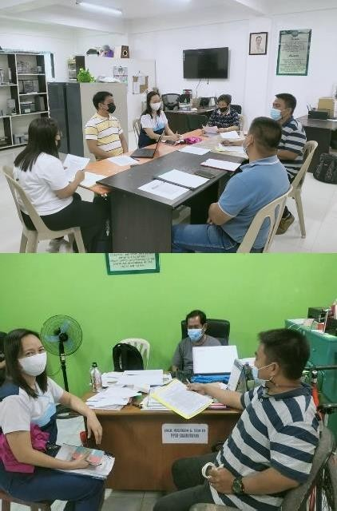

|  |  |  |  |  |  |  |
| --- | --- | --- | --- | --- | --- | --- |
| 50. Coordination meeting, pre assessment Form for limited face-to-face. | March 9, 2022 |  | CCS, COE and CAS, College Deans and Crisis management Committee | LSPU-SC  Engineering Department | UDRRM  and Crisis management Committee |  |
| 51. Coordinated with the PPSD chairperson and UDRRMO faculty president with regards to the materials and requirements for the upcoming F2F (signages and retrofitted facilities) | March 9, 2022 |  | PPSD  chairperson and UDRRMO  Faculty President | PPSD office | LSPU-SC  Nurse and UDRRMO  Faculty President |  |

|  |  |  |  |  |  |  |
| --- | --- | --- | --- | --- | --- | --- |
| 52.Made inspection rounds | March 9, 2022 |  | LSPU Nurse and UDRRMO Faculty President | LSPU-SC  Clinic | LSPU-SC  Nurse and UDRRMO  Faculty President D |  |
| 53. Coordinated with the ICTS chairperson and security officer for implementation of Health Declaration questionnaire thru QR code for students and faculty in the postal system. | March 10, 2022 |  | LSPU Clinic personnel | LSPU-SC  Security Guard Office | LSPU-SC  Nurse |  |

|  |  |  |  |  |  |  |
| --- | --- | --- | --- | --- | --- | --- |
| 54.Attended University wide consultative meeting via zoom with regards to the re-opening of LSPU for limited face-to-face classes. | March 10, 2022 |  | LSPU University Wide Students, parents, Teachers, Administrators and other Stake Holders | Thru zoom | LSPU-SC  OSAS and LSPU  Nurses |  |
| 55. Disseminate Health Information to students, faculty offices and employees of LSPU thru GC with regards to the new computerized documents tracking and signing system for health declaration and other faculty transaction links. | March 11, 2022 |  | LSPU-Sc Faculty, Students and Employees | LSPU-SC | ICTS  Personnel |  |

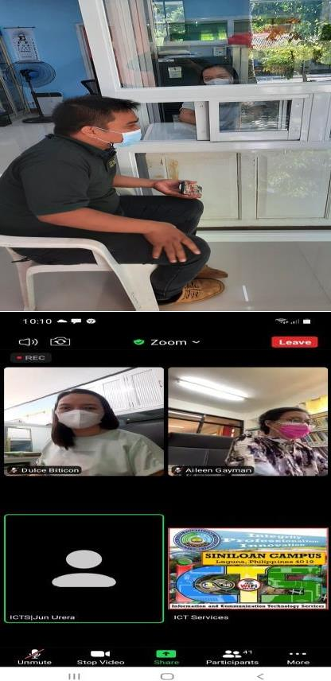

|  |  |  |  |  |  |  |
| --- | --- | --- | --- | --- | --- | --- |
| 56. Coordinated with UDRRM faculty president with regards tothe updates in preparation for limited face to face classes |  |  | UDRRM faculty president | LSPU-SC  Clinic | LSPU-SC  Nurse |  |
| 57. Attended zoom meeting with regards to the LSPU- SC Computerized Document tracking and signing | Match 23, 2022 |  | LSPU employees | Thru zoom | ICTS andMIS Personnel |  |

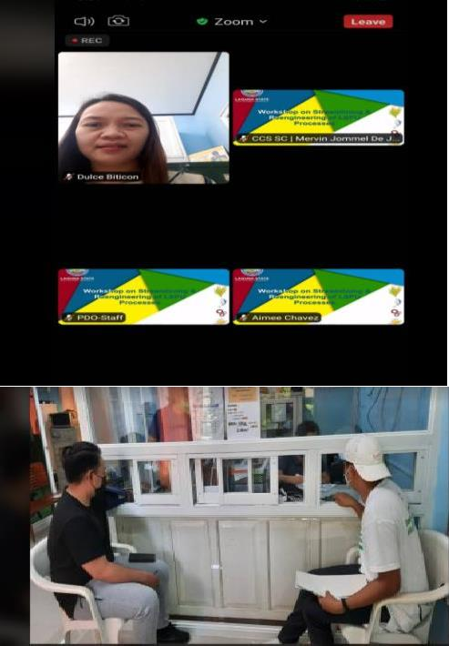

|  |  |  |  |  |  |  |
| --- | --- | --- | --- | --- | --- | --- |
| 58. Attended 2-days workshop on Re-  engineering of LSPU’s System and Processes via zoom | March 24-25, 2022 |  | Admin Senior Officials, University Wide Chairperson and Directors | LSPU-SC  Clinic | Director of PPSD |  |
| 59. Facilitated Physical Exam for Intercampus/ Regional Players | March 24-25, 2022 |  | LSPU Clinic personnel | LSPU-SC  Clinic | LSPU-SC  Nurse |  |

|  |  |  |  |  |  |  |
| --- | --- | --- | --- | --- | --- | --- |
| 60. Visited the plan of isolation room located at the mini hotel | March 28, 2022 |  | LSPU Clinic personnel | LSPU-SC  Clinic | LSPU-SC  Nurse |  |

|  |  |  |  |  |  |  |
| --- | --- | --- | --- | --- | --- | --- |
| 61. Attended ROAT evaluation of BS Agribusiness program of LSPU via zoom | March 29, 2022 |  |  | LSPU-SC |  |  |
| 62. Attended the meeting with the University wide crisis management committee members to monitor and evaluate THE self-assessment checklist on the readiness of LSPU-SC campus to reopen for  limited face to face classes | March 29, 2022 |  |  | LSPU-SC |  |  |

|  |  |  |  |  |  |  |
| --- | --- | --- | --- | --- | --- | --- |
|  |  |  |  |  |  |  |
| 63. Coordinated with the RHU sanitary officer and UDRRM faculty presidents with regards to the evaluation of the self-assessment checklist for the preparations for the limited face to face classes | March 30, 2022 |  | RHU sanitary officer and UDRRM faculty president | LSPU-SC | LSPU-SC  Nurse |  |

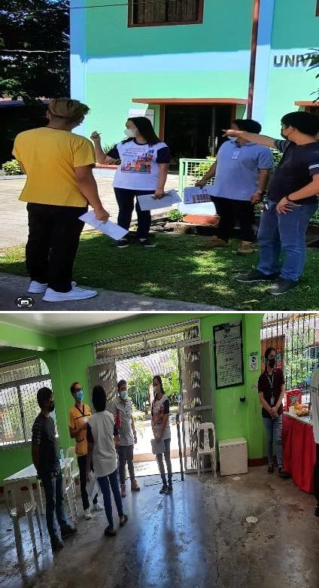

|  |  |  |  |  |  |  |
| --- | --- | --- | --- | --- | --- | --- |
|  |  |  |  |  |  |  |
| 64. Performed campus rounds with the RHU sanitary officer. | March 30, 2022 |  | RHU sanitary officer and UDRRM faculty president | LSPU-SC | LSPU-SC  Nurse |  |

|  |  |  |  |  |  |  |
| --- | --- | --- | --- | --- | --- | --- |
| 65. Coordinated with the PPSD Chairperson with regards to the recommendation of RHU for the requirements of limited face to face  classes | March 30, 2022 |  | LSPU-SC Nurse and UDRM Faculty President and PPSD Chairperson | Farm mechanics | LSPU-SC  Nurse and UDRM  Faculty President |  |
| 66. Participated with the GAD activity and gave Health reminders with regards to the health protocols while ongoing health and wellness activity | March 30, 2022 |  | LSPU-Sc Faculty and employees | LSPU-SC  Gymnasium | GAD |  |

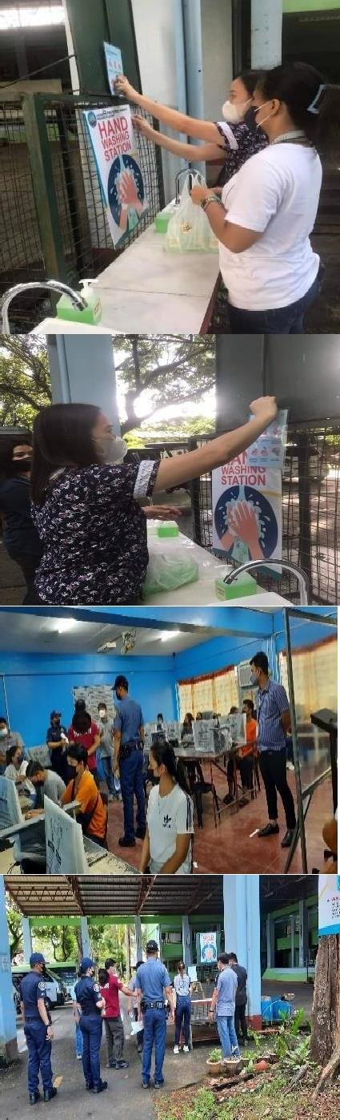

|  |  |  |  |  |  |  |
| --- | --- | --- | --- | --- | --- | --- |
| 67.Posting of signages with regards to the health protocols in compliance with the requirements of LGU for limited face to face classes | March 31, 2022 |  | LSPU-SC Nurse and CCS OJT students | VOAG  Building and CCS department | LSPU-SC  Nurse |  |
| 68. Made ocular visit and evaluation on the areas covered for limited face to face together with BFP, LGU and Crisis management committee | March 31, 2022 |  | BFP, LGU and Crisis management committee | LSPU-SC | LSPU-SC UDRM  Faculty President |  |

|  |  |  |  |  |  |  |
| --- | --- | --- | --- | --- | --- | --- |
| 69. Attended the pre and post conference meeting with the evaluators committee of LGU and LSPU Crisis management with regards to their recommendation and requirements that need to be accomplishment for limited face to face classes | March 31, 2022 |  | LGU Inspection Team, DILG- Jennifer O. Zaide- Tolentino ,  MDRRMO-  Ronaldo D. Cajano and Mark Nikko A. Rulida, BFP- SF02 May P Bascogin and FO1 Jerdan C. Buquid, RHU- John Paul B Valdivia, RN, LPT and 2  representative from PNP Siniloan | LSPU-SC  conference Room | LSPU-SC UDRM  Faculty President |  |

|  |  |  |  |  |
| --- | --- | --- | --- | --- |
| **PROGRAM/ACTIVITY/**  **PROJECT** | **PERFORMANCE**  **MEASURES** | **ACCOMPLISHMENT** | **PICTORIAL** | **REMARKS** |
| INTERNATIONAL LOCAL AFFAIRS UNIT | | | | |
|  |  |  | C:\Users\GAD\Downloads\277317556_5016874865062469_1470856880578436684_n.jpg | Accomplished |
| Attendance to ILA | The ILA Director conducts | The ILA unit conducted |  |
| QuarterlyMeeting on | atleast one (1) meeting | the quarterly meeting to |  |
| January 25, 2022 | every quarter with the unit | discuss the ILA plan of |  |
|  | Chairpersons of the four | activities for the first |  |
|  | campuses regarding the | quarter of A.Y.2022-2023 |  |
|  | plan of activities and |  |  |
|  | undertakings of the unit for |  |  |
|  | the first quarter of the |  |  |
|  | A.Y.2022-2023 |  |  |

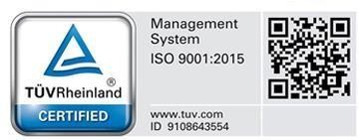Republic of the Philippines

|  |  |  |  |  |
| --- | --- | --- | --- | --- |
| **ACC** | **OMPLISHMENT REPORT** | Laguna State Polytech  Province of La  **OF ALL UNITS UNDER**  **LSPU SINILOA**  **January to** | nic University  guna  **THE OFFICE OF STUDENT AFFAI**  **N (Host) CAMPUS**  **March 2022** | **RS AND SERVICES** |
| Attendance to an online | The ILA unit attends to at least | The ILA unit Director | C:\Users\GAD\Downloads\277075472_559688838830969_8695893658481273876_n.jpg  C:\Users\GAD\Downloads\277689627_5302699153118314_4429184770268974904_n.jpg | Accomplished |
| conference and webinars  like | one (1) seminar, trainings  and | Sandra P. Mesina  attended to |
| UKM Global Webinar  Series | conference per  quarter | two (2) online/webinar  on |
| on January 25, 2022 and | regarding ILA programs. | Philippine  Educatio  n |
| PETC 2022 on January  26, |  | Tourism Conference(1  day |
| 2022 |  | only) and UKM Global |
|  |  | Webinar Series: The |
|  |  | International Mobility |
|  |  | Experience of Students from |
|  |  | Malaysia and  Japanese |
|  |  | Universities. |

|  |  |  |  |  |
| --- | --- | --- | --- | --- |
|  |  |  |  |  |
| Attendance to | The ILA officers attend to | Attended to the |  | Accomplished |
| the | the academic or program | Program Accreditation |  |
| Accreditation | accreditation activity | activity and prepared |  |
| Reorientation | concerned with student | needed documents that |  |
|  | support. | shows support to |  |
|  |  | foreign and Filipino |  |
|  |  | students on their |  |
|  |  | academic requirements |  |
|  |  | andinternship activity |  |

|  |  |  |  |  |
| --- | --- | --- | --- | --- |
| Attendance to the Deliberation of OPCR 2021 and setting of targets for  A.Y. 2022-2023 on January 28,  2022 | The ILA unit Director attends to at least one administrative meeting for academic, research and extension activities or program undertakings. | The ILA Director attended tothe deliberation of OPCR 2021 conducted by the Planning Office |  | Accomplishe d |

Republic of the Philippines

|  |  |  |  |  |
| --- | --- | --- | --- | --- |
| **ACCO**  Attendance to  administrative meeting for accreditation activity on February 14, 2022 and review with presentation of the LSPU Annual Report 2021 conducted on  February 23, 2022 . | Lagu  **MPLISHMENT REPORT OF**  The ILA unit attends to at least two administrative meeting for academic, research and extension program review and planning. | na State Polytechnic U  Province of Laguna  **ALL UNITS UNDER TH**  **LSPU SINILOAN (Host**  **January to March**  Attended the  Administrative Council Meeting conducted on February 14, 2022 and witnessed the review and presentation of LSPU Annual Report 2021 on February 23, 2022 | niversity  **E OFFICE OF STUDENT AFFAIRS AN**  **) CAMPUS 2022** | Accomplishe d  **D SERVICES** |

Republic of the Philippines

# Laguna State Polytechnic University

Province of Laguna

ACCOMPLISHMENT REPORT OF ALL UNITS UNDER THE OFFICE OF STUDENT AFFAIRS AND SERVICES

LSPU SINILOAN (Host) CAMPUS

January to March 2022

|  |  |  |  |  |
| --- | --- | --- | --- | --- |
| Conduct of Review of ILA OPCR indicator and target setting. | The ILA unit conducts atleast one activity related to OPCR review of accomplishment and target setting for the A.Y 2022 | Conducted a review of the ILA plan of activities and revision OPCR indicator andmeasures. | C:\Users\GAD\Downloads\274952512_1612684575776260_56972244726075028_n.jpg | Accomplished |
| Coordination with Academic partners for students activities and enhancement of international  academ ic programs. February 17, 2022 | Coordinate and communicate with the existing and active academic partners within the academic year. | Coordinated with the representative  o  f WorldwideLink Educational Foundation for proposedactivity and search for foreign educators as resource speaker for future activity ofthe unit. | C:\Users\GAD\Downloads\277241383_519756499669179_3026099297615956007_n.jpg | Accomplished |

Republic of the Philippines

|  |  |  |  |  |
| --- | --- | --- | --- | --- |
| **ACC**  Assistance to  Foreign students academic activity | **OMPLISHMENT REPORT**  Assists the foreign students ontheir academic activity  . | Laguna State Polytech  Province of La  **OF ALL UNITS UNDER**  **LSPU SINILOA**  **January to**  Assisted and facilitated the enrolment process of one foreign students named Ms. Do Ngoc Uyen enrolled in BS Psychology for 2nd semester A. Y. 2021-2022 | nic University  guna  **THE OFFICE OF STUDENT AFFAI**  **N (Host) CAMPUS**  **March 2022**  C:\Users\GAD\Downloads\277894107_2165084563657126_8420589120452245627_n.jpg | **RS AND SERVICES**  Accomplished |

Republic of the Philippines

# Laguna State Polytechnic University

Province of Laguna

ACCOMPLISHMENT REPORT OF ALL UNITS UNDER THE OFFICE OF STUDENT AFFAIRS AND SERVICES

LSPU SINILOAN (Host) CAMPUS

January to March 2022

|  |  |  |  |  |
| --- | --- | --- | --- | --- |
| Attendance to Virtual Consultative assembly and Orientation on Limited Face to face for LSPU Program on March 10, 2022 | Attend to atleast one activity onstudent services . | Attended to the Virtual consultative assembly and orientation on Limited Face to face on March 10, 2022 | C:\Users\GAD\Downloads\275380642_1162405504564530_1800899758205734917_n.jpg | Accomplished |
| Attendance to Virtual Orientation on  International Online courses provided by SEAMEO on March 17, 2022 | Attend to at least one webinar related to International affairs, programs and linkages. | Attended the Orientation onSEAMEO online course | C:\Users\GAD\Downloads\277215712_645415663511458_2186421294600309059_n.jpg | Accomplished |

Republic of the Philippines

|  |  |  |  |  |
| --- | --- | --- | --- | --- |
| **ACC** | **OMPLISHMENT REPORT** | Laguna State Polytech  Province of La  **OF ALL UNITS UNDER**  **LSPU SINILOA**  **January to** | nic University  guna  **THE OFFICE OF STUDENT AFFAI**  **N (Host) CAMPUS**  **March 2022** | **RS AND SERVICES** |
| Attendance to the  Reengineering workshop on Streamlining on March 24-25, 2022 | Attend to at least one virtual seminar workshop related to students services and functions. | Attended to the virtual seminar workshop on Reengineering  an d streamlining of services ofthe ILA unit. | C:\Users\GAD\Downloads\278090689_349305430493514_5137406456095490221_n.jpg  C:\Users\GAD\Downloads\277854700_510751513841270_7455340794504688031_n.jpg | Accomplished |

|  |  |  |  |  |
| --- | --- | --- | --- | --- |
| Attendance to the webinar related to Gender and Development during the International Women’s month 2022 on March 28, 2022 | Attend to atleast one webinar related to Universty’s activities like Women’s Month Celebration | Attended to a webinar related to University’s activities like Women’s Month Celebration entitled “ABAN-TEH! Who is the Modern Filipina? Women canVi Leaders. March 28, 2022 | C:\Users\GAD\Downloads\277614289_504655197789988_4157419406294526389_n.jpg  C:\Users\GAD\Downloads\277596965_371675608188878_833933565031011387_n.jpg | Accomplished |

|  |  |  |  |  |  |  |
| --- | --- | --- | --- | --- | --- | --- |
| **TITLE OF ACTIVITIES/ PROGRAM** | **DATE/ DURATION** | **DOCUMENTATION (PICTURES)** | **PARTICIPANTS** | **LOCATION** | **CONDUCTED/**  **SPONSORED BY:** | **BUDGET/ REMARKS** |
| **OFFICE OF STUDENT AFFAIRS AND SERVICES** | | | | | | |
| Validated student I.D.(s) | January to March 2022 | Refer to OSAS Log Book/Document | LSPU  students | Office of Student Affairs and Services | OSAS |  |

|  |  |  |  |  |  |  |
| --- | --- | --- | --- | --- | --- | --- |
| Posted and disseminated relevant announcements and information pertaining to student services on OSAS Official Facebook Page / Social Media | January to March 2022 |  | LSPU  students | Office of Student Affairs and Services Facebook Official Page | OSAS |  |

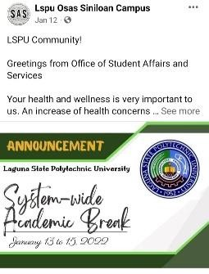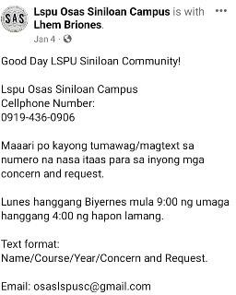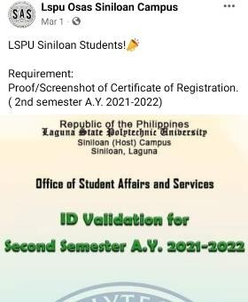

|  |  |  |  |  |  |  |
| --- | --- | --- | --- | --- | --- | --- |
| Signed Semestral Clearance/s | January to March 2022 |  | LSPU students | Office of Student Affairsand Services | OSAS |  |

|  |  |  |  |  |  |  |
| --- | --- | --- | --- | --- | --- | --- |
| Renewal of Students Body Organization | January 05, 2022 |  | LSPU students Organizations | Office of Student Affairsand Services | OSAS |  |
| Recommendation of Unit Heads Designation | January 10,2022 | C:\Users\James Simmond\Desktop\DDDD.png | OSAS Director & Chairperson Faculty Members | Office of the Director, OSAS | Chairperson, OSAS |  |

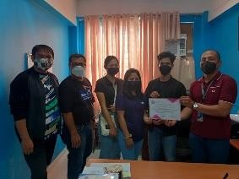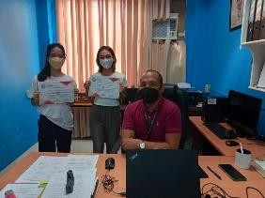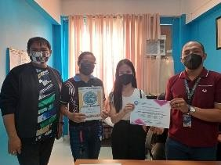

|  |  |  |  |  |  |  |
| --- | --- | --- | --- | --- | --- | --- |
| Conducted survey thru online platform pertaining to COVID-19 Student Profile | January to March 2022 |  | LSPU  Students | Online Platform | OSAS |  |
| Assisted in receiving and attending to student concerns related to student services via phone calls, chat, video conferencing in relation to Student Concerns Desk | January to March 2022 | C:\Users\James Simmond\Downloads\175652671_913197669463618_5204107302694987510_n.jpg | LSPU students | Online Platform | OSAS |  |

|  |  |  |  |  |  |  |
| --- | --- | --- | --- | --- | --- | --- |
| Conducted survey thru online platform pertaining to satisfaction on the services of the office | January to March 2022 |  | OSAS ICTS  LSPU Students | Online Platform | OSAS |  |
| Attended Gary Virtual Face to Face University Wide Counseling Services Unit Psychoeducational Growth session. | February 18, 2022 |  | LSPU Employee | Online Platform | Guidance |  |

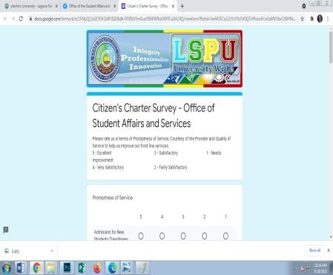

|  |  |  |  |  |  |  |
| --- | --- | --- | --- | --- | --- | --- |
| Turn over of 300 free sim card from SMART for LSPU students | March 03, 2022 |  | Concerned Offices | LSPU Santa Cruz Campus | SMART |  |
| Meeting Coordination with LGU Siniloan Re- Limited Face to Face classes. | March 08, 2022 |  | Concerned Offices | Municipality of Siniloan | LGU Siniloan, LSPU Admin Council |  |

|  |  |  |  |  |  |  |
| --- | --- | --- | --- | --- | --- | --- |
| Conducted University Wide Consultative Meeting on Reopening of LSPU for Limited Face to Face Classes. | March 10, 2022 |  | LSPU Community | Online Platform | OSAS |  |
| Chairperson of OSAS, Unit Heads of Students with special needs, Guidance Counselor Face to Face Meeting | March 18, 2022 |  | OSAS, GAD,  Guidance | LSPU San Pablo Campus | OSAS |  |

|  |  |  |  |  |  |  |
| --- | --- | --- | --- | --- | --- | --- |
| Presentation to E- Finance Board Re: Student Assistance Program at Los Baños Campus | March 29, 2022 |  | Concerned Offices | LSPU San Pablo Campus | OSAS |  |
| Assisted LSPU-SC GAD, Sports & Cultural & Medical Unit on the conducted of Busog na Isipan Malusog na pangangatawan para kina Juana at Juan. | March 30, 2022 |  | LSPU Employee | LSPU Siniloan Campus | GAD, Medical Unit & Sports and Cultural |  |

Prepared by:

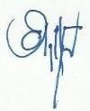**Noted:**

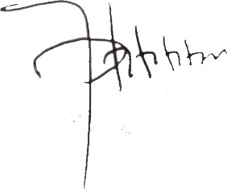

**LEMUEL L. BRIONES**

*OSAS, Admin Aide*

**JAYSON N. OLAYTA**

*Director,OSAS*

**ATTY. RUSHID JAY S. SANCON, LL.M.**

*Campus Director*

Submitted to:

MERVIN JOMMEL T. DE JESUS

*Chairperson, Management Information System*